Intro:
Program 1:
To run the saved sublime file.
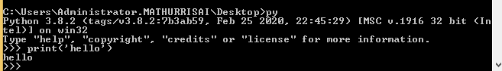
To print in the cmd prom
Variables:
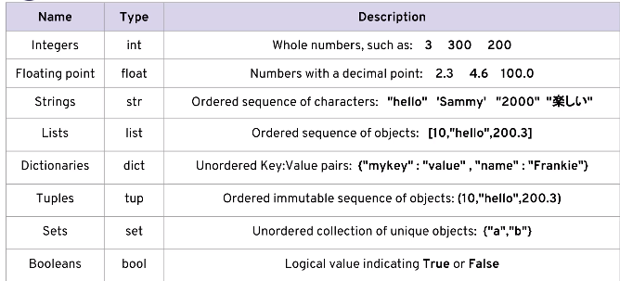

Python is dynamic typing.
For ex : a = 2
And later a can be assigned as a=[1,2,3]
If suppose a = a+a
Then a = 4. Again a=a+a
Then a = 8.
To know the type:
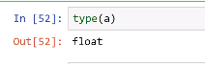
For other lang ike c++:
Eg – int a = 2
And a cannot be assigned later as a=’hello’.

String:

Indexing:
By using indexing which can be implemented by using [] helps to take a single charac from the string.
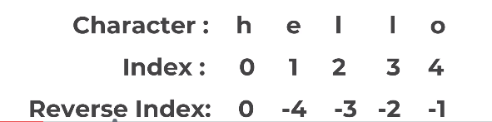
To get the first character:
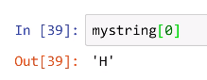
Eg:
A=”abcdefg”
Mystring[7] will give “g”.
AS well Mystring[-1] will also give “g”.

Slicing:
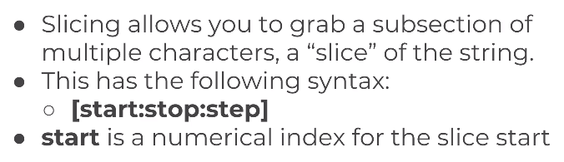
Will take the
Mystring = “abcdefg”
A=0,b=1,c=2,d=3..
So 2: will take or start from that place.
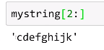
After : will take upto that number
Here 3 is d. So it will take the charac before 3.
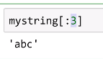
To take the necessary strings:
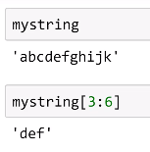
To skip by 3
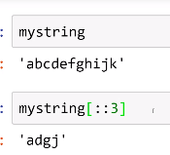
Start at 2 so c is 2 here.
Stop at 7 where h is 7 so it must stop by g
Skip by 2 so c,d,e,f,g is skipped by 2 so the result is ceg.
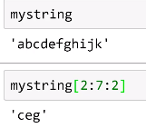
To reverse the string:
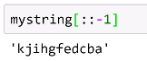

Immutabilty:
Means it cannot be changed.
The String cannot be changed.
P1:
When we try to change the string it will produce error.
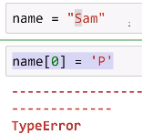
We assign the am from the name to last_letter and concatenate with P to change as Pam.
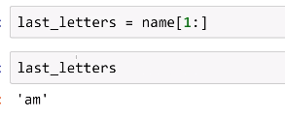
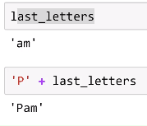
P2:
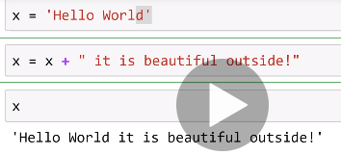
When it is ran more than one time then:
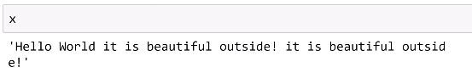
P3:
To multiply letters.
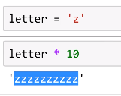

P4:
X=’Hello World’.
Then x on another column and press tab.
It wil list all the attributes and methods.
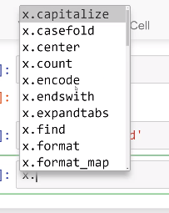
P5: Split will split ‘Hello World’ as :
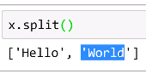
P6: before it was split by space since the () was empty.dist
When i is mentioned then it will spilt everything by ‘i’.
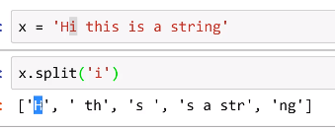

Print Formatting with String:
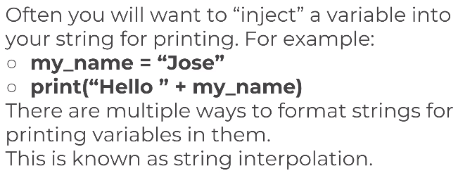
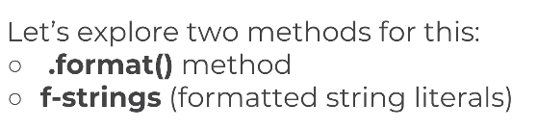
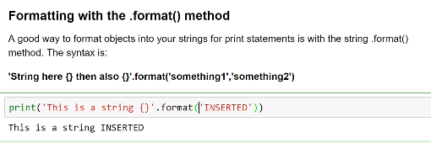
P7:
{} – how many words we insert.
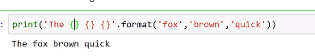
To change the order:
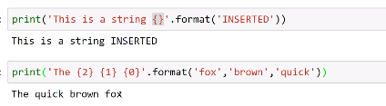
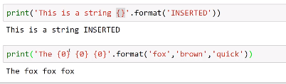
We can use the keywords to call
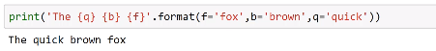
P8:
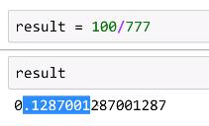
To insert float value into a string:
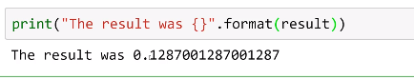
Method 2:
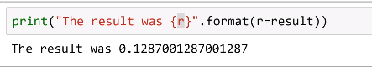
R is the actual value.
1 is the width how long the result is should be
The last one precision is teh round of for 0.1287001 if we round of by 3 then it will be 0.129
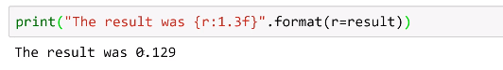
When width is increased.
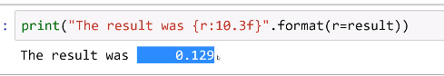
P9:
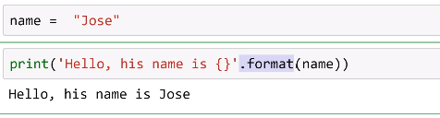
To replace the .format.
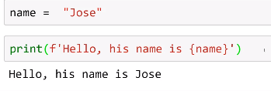
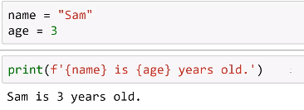
P10:
% r will include the quotation:
but you should note that %r and repr() deliver the string representation of the object, including quotation marks and any escape characters.
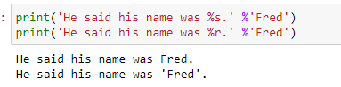
Why not to use %r:
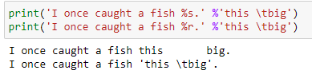
P11:
Example for multiple formatting:
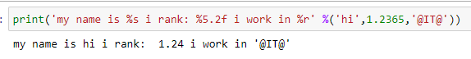
Float formatting example:
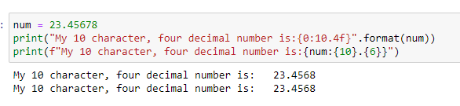

List:
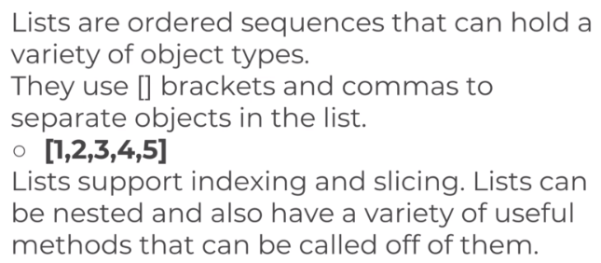
P12: List elements can be modified.
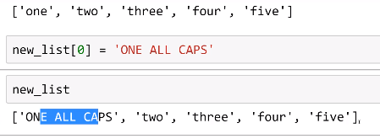
Append:
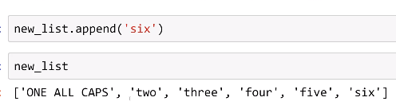
To remove the last number:
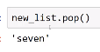
Once pop is used

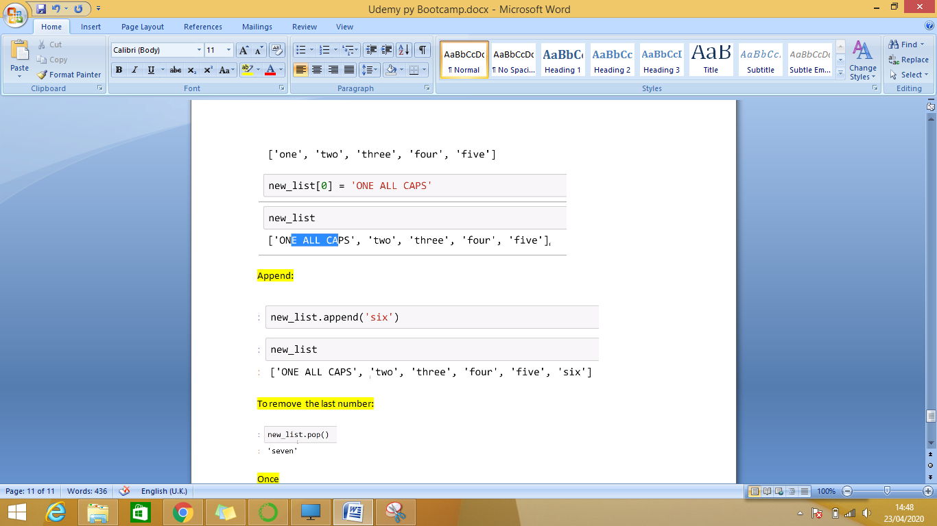
To remove particular position.
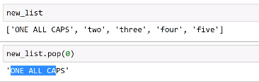
P13: Sort
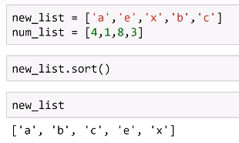
We cannot re assign the result t another.
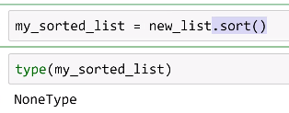
In order to re-assign
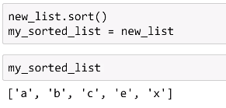

Dictionaries:
When to use key and when to use list.
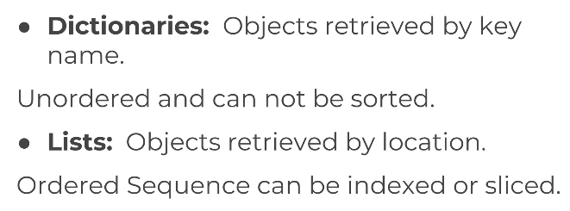
P 14:
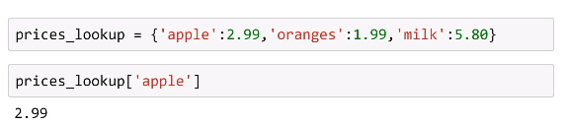
Dict can hold list as wel other dict.
[0,1,2] is a list and {‘insidekey’:100} is other dict.
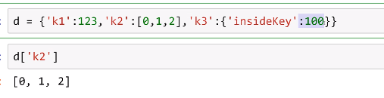
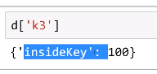
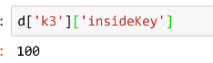
To pick a particular:
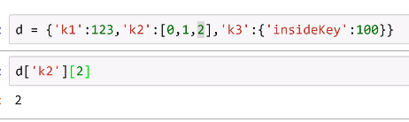
To chnagethe leetr c to upper case.
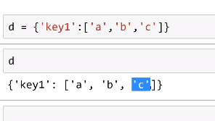
First change the dict to list
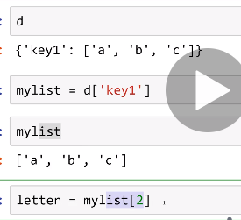
Take that letter and change the case.
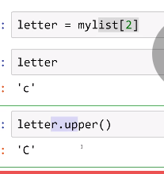
Alternate easy method:
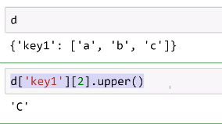
To add a new keypair:
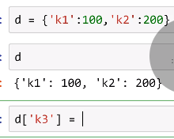
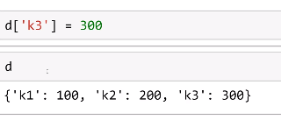
Over write existing key value:
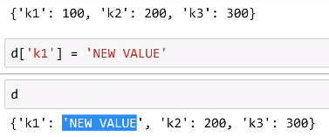
Xtra:
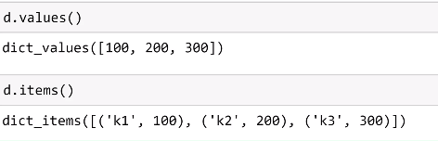
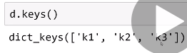

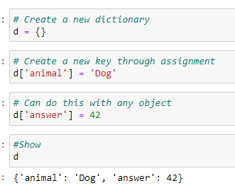

Tuples:
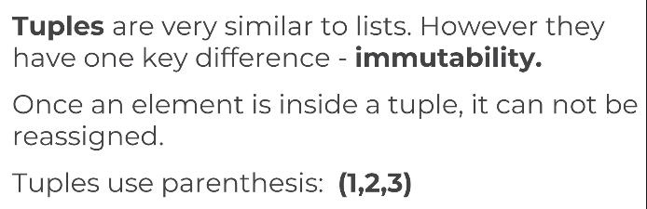
Diff between tuples and list is that tuples use () and list use [].
P15:

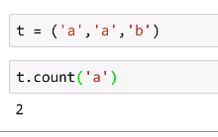.
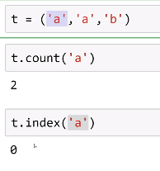
How many times ‘a’ occurs in tuple.
Tuples are immutable i.e it cannot be changed
Where as list is mutable i.e a list can be changed.
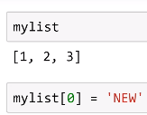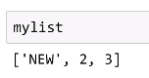
In tuple:
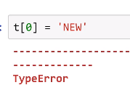

Sets:
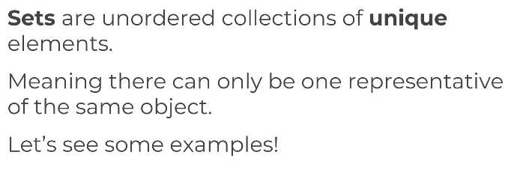
Set will have the unique value in them if we add the same value to them it will not accept it.
P16:
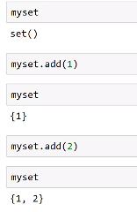
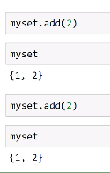
Adding 2 second time doesn’t make any difference.
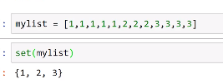
Set do not follow any order.it will follow what order the value is arranged.
It is an unordered collection of unique elements.

Booleans
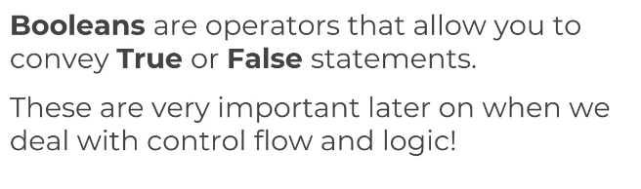
T of True and F of False should be capitalised or will throw error.
P17:
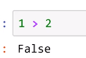
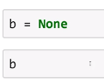
There is a data type called ‘none’.

I/O with basic files:
File created here will be stored in the system.
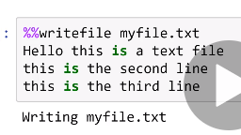
When we try to open a file which doesn’t exist then it will throw error
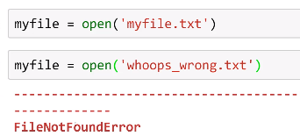
To know the directory:
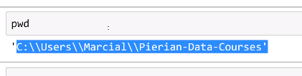
To read a file
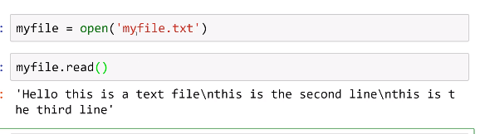
/n indicates the new line
When we read the file again
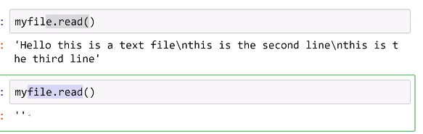
This is bcoz there will be a cursor at the starting of the line.
When read the cursor will come to the end.
So we need to reset the cursor before reading it the other time.
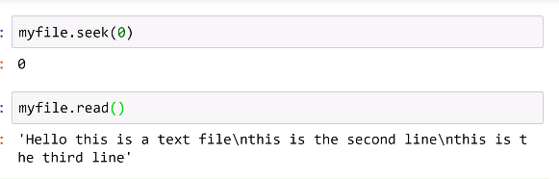
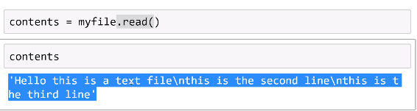
Each line separately: 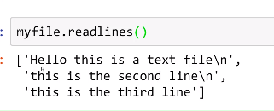
To read files other than the mentioned directory.
Close the file later:
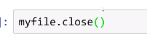
When the file is opened somewhere in the system and when we try to close then it will throw error.
In order, to overcome that we need to use this method:
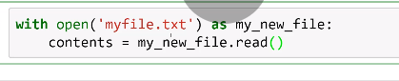
Here provide a variable name which is my_new_file here.
Then assign them to contents. So later there is no worry of closing this file.
Press shift+tab
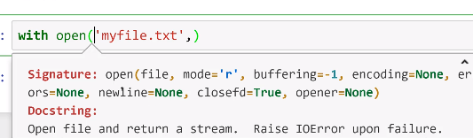
Copy mode=’r’ and paste it inside.
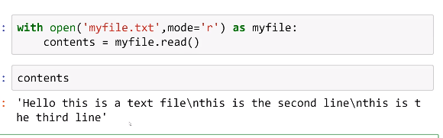
It will read when ‘r’.
But when changed to ‘w’ it will throw error.
We use ‘w’ to overwrite files.
a – to append files.
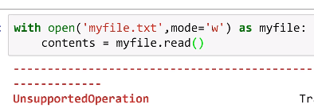
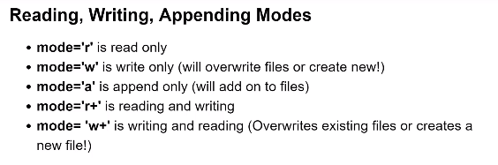
When running the file again
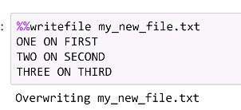
To append file:
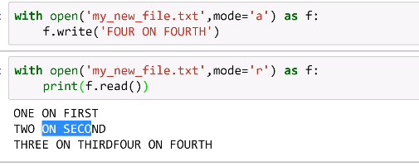
To add in next line:
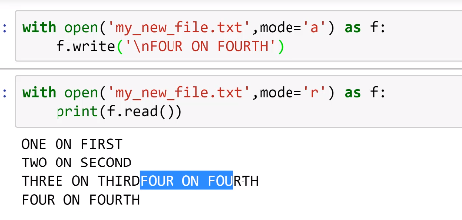
By using w. If teh file already exist then it will overwite if not then it will create anew one.
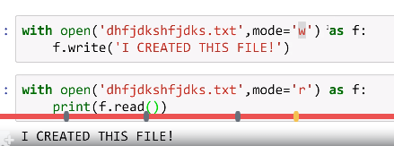

Diff:
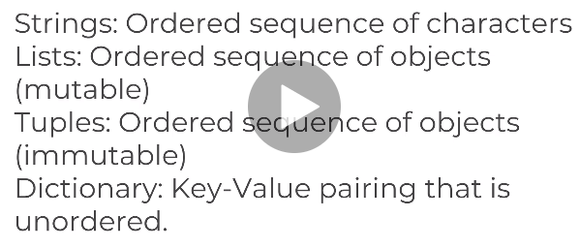

Python Statements:
If
else if
else statements.
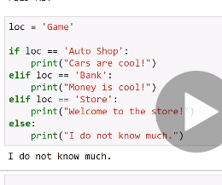
Iteration: 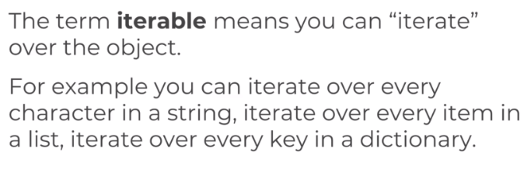
Eg:
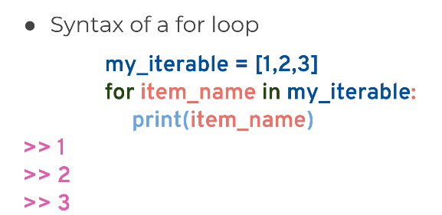
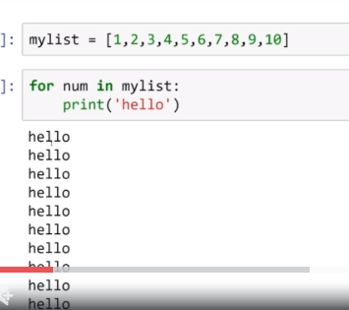
My list contais numb 1 to 10.
Num is the var name here it can be changed as per user need.
So it prints ‘hello’ 10 times since there are 10 numbers in mylist.
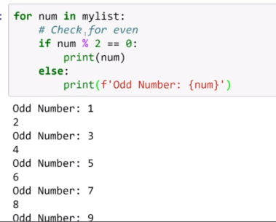
From 1 to 10 in mylist
If divided by 2 then it will print the numb as it is.
If not then it will print the odd number.
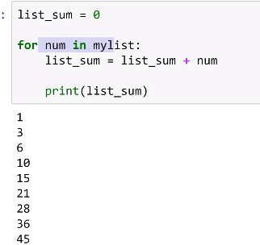
List_num=0,1,2,3,4,5,6,7,8,9,10
List_sum=list_sum=num
List_num=0+1=1 now list_num=1
1+1=2
2+1=3
3+3=6
6+4=10
10+5=15
15+6=21
21+7=28 etc...
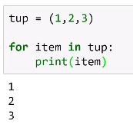
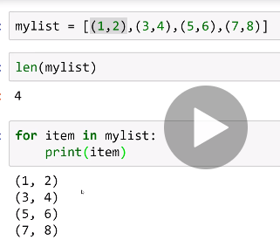
To print sibgle item in the above mentioned tuple:
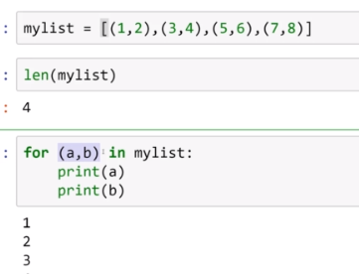
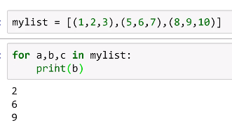
When we iterate teh dict :
It will only iterate the key.
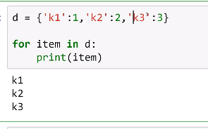
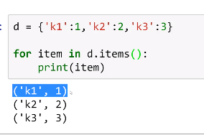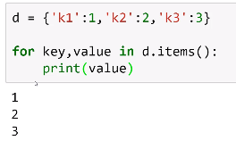
While:
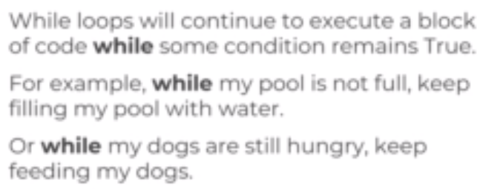
Condition:
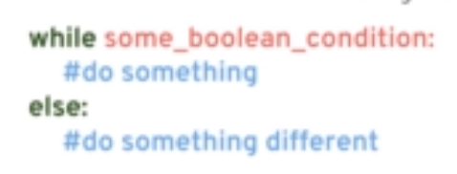

P18:
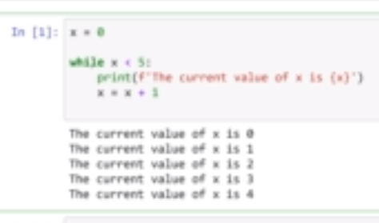
Instead of x=x+1
We can write x+=1
Both gives same output.
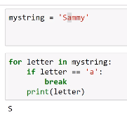
P19:
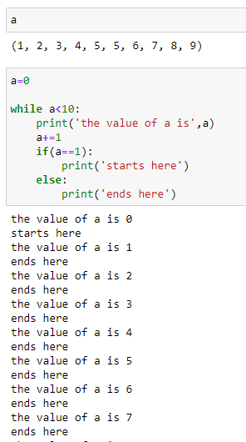
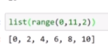

P20:zip and in operator:
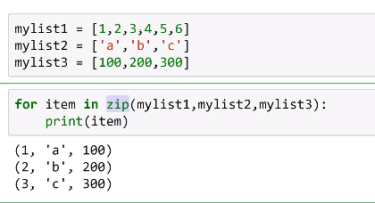
Thogh various data set length it will take only the min and iterate.
Booleann:
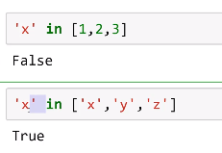
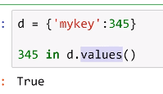
Built in func: min and max are built in func:
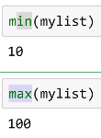
P21: iMPORT
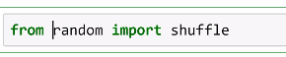
Random is already a built in lib.
Shuffle is a func associated with that lib.
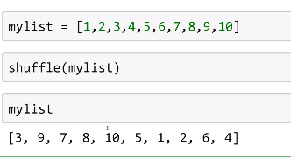
Shuffled.
It cannot be assigned to any
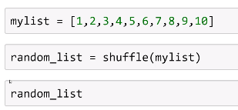
It will nit return any.
When checked fr its type it will be none.
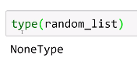
P22:
It will pick a random int.
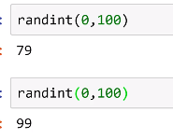

P23:input
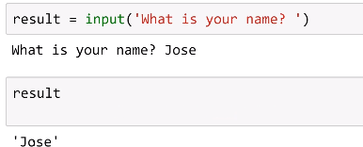
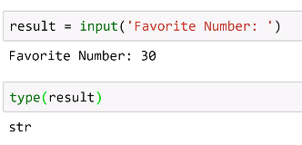
To change the data type:
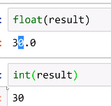
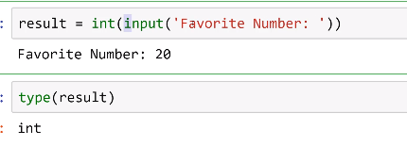

Comprehension
P24:
Instead of For Loop:
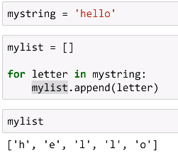
Instead we can use this:
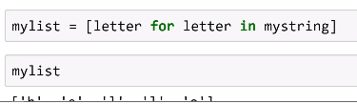
Produce same output
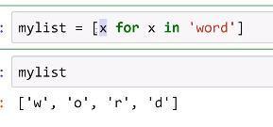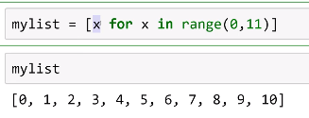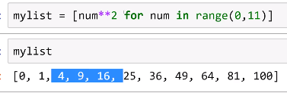
It is done by flatteining for loop
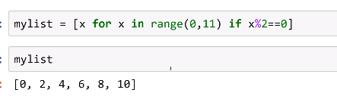
Here we do modulo for range 0 to 11.
Method1 :
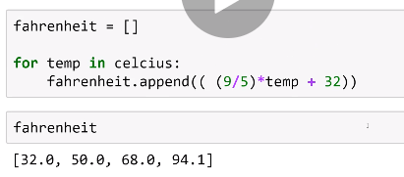
Method 2:
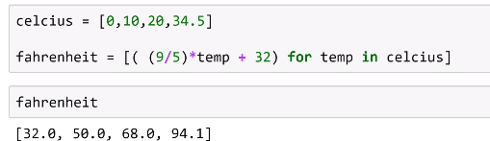

P25:To use if-else inside list comprehension.
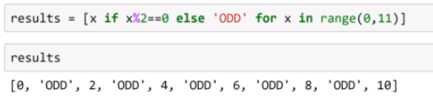
Nested loop:
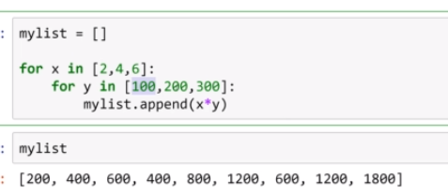
Comprehension method;
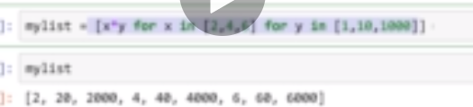
Mylist=[x*y for x in [2,4,6,] for y in [1,10,1000]]
Mylist

Functions:
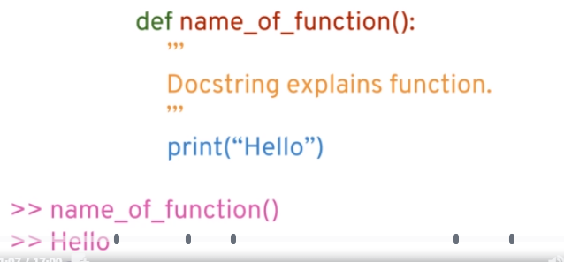

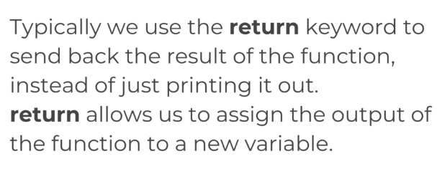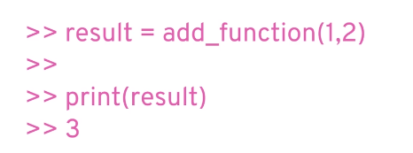
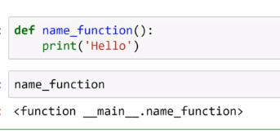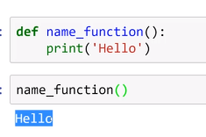
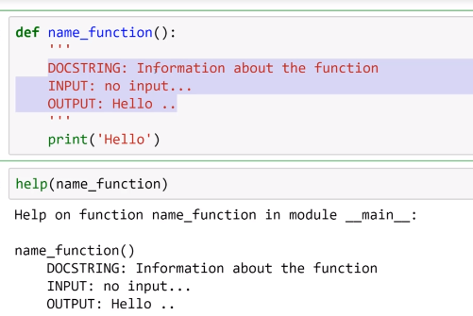
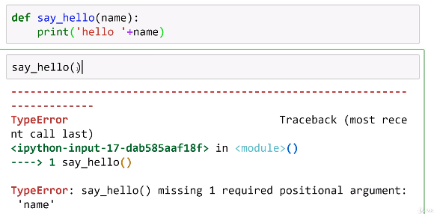
Thebaove throws error since name argument i snot paeesd.
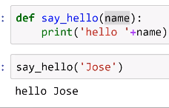
In the below code we provide a default arg name
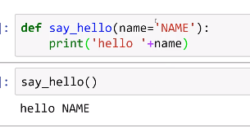
Though if we don’t pass the value to the arg it willtake the default name.
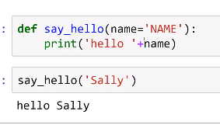
So it will not ask for any arg name
When the func need to called somewhere it should return not print
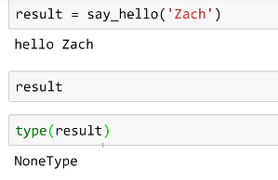
So when the print type wa checked it is ot returning anything.
So the argument must be returned.
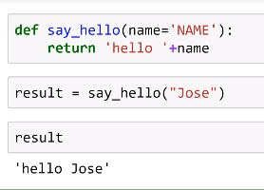
So here return is used .when the func it called then it will return its value.by using return there is no need to rewrite the code.
We can return the func and use.
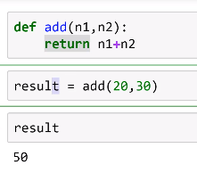
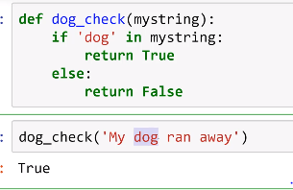
Same when ran with D upper case
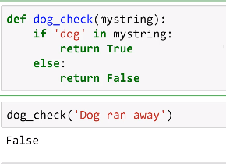
To overcome this we are going to make the entire string as lower case by:
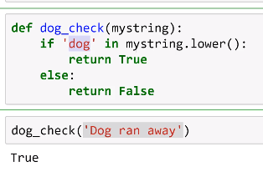
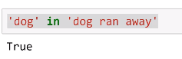
When we ran the above statement it throws false since it was in if condiit will return as Boolean.
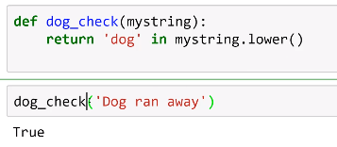
Even return will do thesame task
Pig Latin:
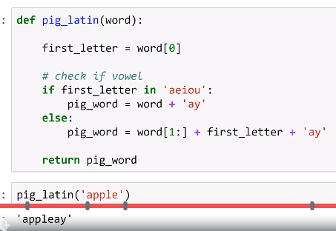
Args and Kwargs:
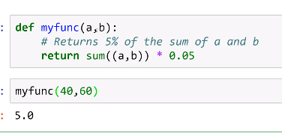
here a and b are passed as tuples.
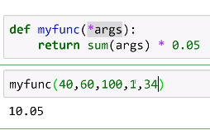
By using *args we don’t need to call the parameters or pass the parameters.
We can pass as many we need.
Instead of args we can use any keyword starting with *
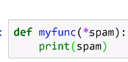
Args written tuple.
But kwargs return dictionary.
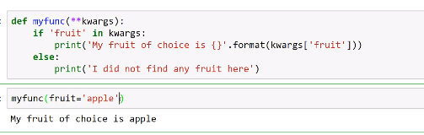
It prints fruit as apple.
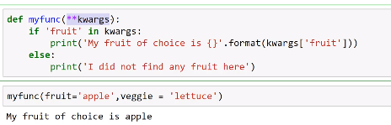
Now it doesn’t print veggie.
So when we print the dic at beginning by adding code.
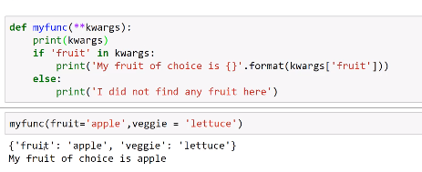
It shows dic that the fruit is attaché dt o apple and lettuce to veggie.
So when we alter the code and print it will print the same result:
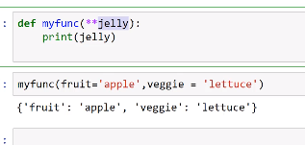
Using both args and kwargs:
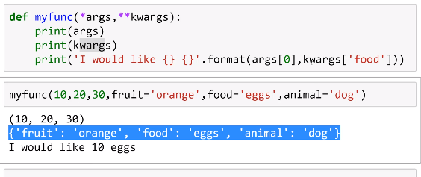
Args will take only values and kwargs will take any in the form of dictionary.
Args should be followed by kwargs.
Else will throw error
